7.2.15 Editors - 3D View - Header - Mesh - Sculpt mode - Mask menu
Sculpt Mode - Mask Menu 1
Invert Mask 1
Fill Mask 1
Clear Mask 1
Box Mask 1
Lasso Mask 1
Smooth Mask 2
Sharpen Mask 2
Grow Mask 2
Shrink Mask 2
Increase Contrast 2
Decrease Contrast 2
Expand Mask by Topology 2
Expand Mask by Curvature 2
Mask Extract 2
Threshold 2
Add Boundary Loop 2
Smooth Iterations 3
Project to Sculpt 3
Extract as Solid 3
OK 3
Dirty Mask 3

Sculpt Mode - Mask Menu

Invert Mask
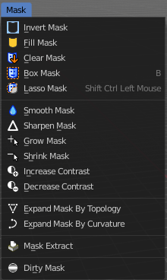
Inverts the mask.

Fill Mask
Fills the mask with a given value, or inverts its values.

Clear Mask
Clears the mask.

Box Mask
Select part of the mesh with a Rectangle tool.

Lasso Mask
Select part of the mesh with a lasso tool.
Hotkey only tool, since the menu item is a bad starting point.

Smooth Mask
Smoothens the mask selection.

Sharpen Mask
Sharpens the mask selection.

Grow Mask
Grows the mask

Shrink Mask
Shrinks the mask.

Increase Contrast
Increases the contrast between masked parts and not masked parts.

Decrease Contrast
Decreases the contrast between masked parts and not masked parts.

Expand Mask by Topology
Expands the mask from the initial active vertex under the mouse. Starts with a new mask.
Watch the tooltip in the footer for further instructions.

Expand Mask by Curvature
Expands the mask from the initial active vertex under the mouse. Keeps the previous mask.
Watch the tooltip in the footer for further instructions.

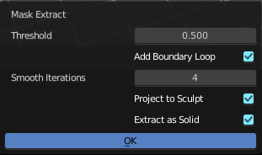
Mask Extract
Creates a new object out of the masked mesh part.
This operation cannot be undone!

Threshold
The sharpness of the mask border.

Add Boundary Loop
Add a boundary loop at the border of the new created geometry. This can help to make the geometry more stable.

Smooth Iterations
How many iterations to smooth the new created geometry.

Project to Sculpt
Project the extracted mesh into the original sculpt.

Extract as Solid
Extract the new created mesh as a solid mesh.

OK
Apply the Mask Extract tool.

Dirty Mask
Creates a mask based on cavity and pointiness of the mesh.

